### **Task 2 : Absolute and Relative Paths**

**Create an empty file named exercise.md and move this file to the /tmp directory, using a relative pathname. Then, delete this file using an absolute pathname.**

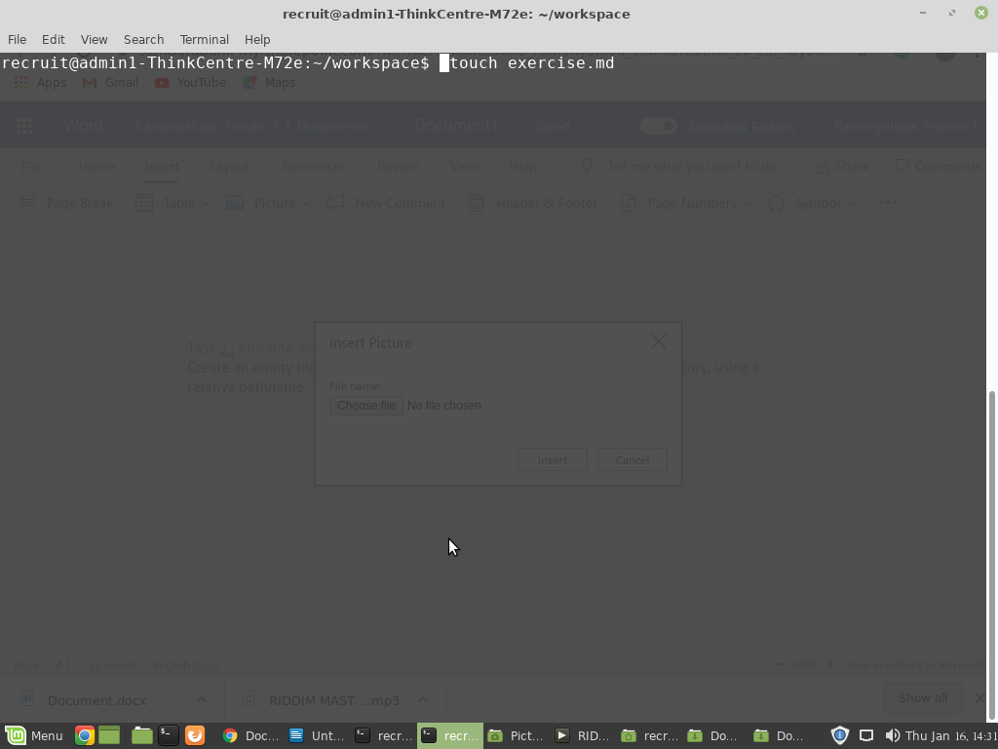

Create file named exercise.md

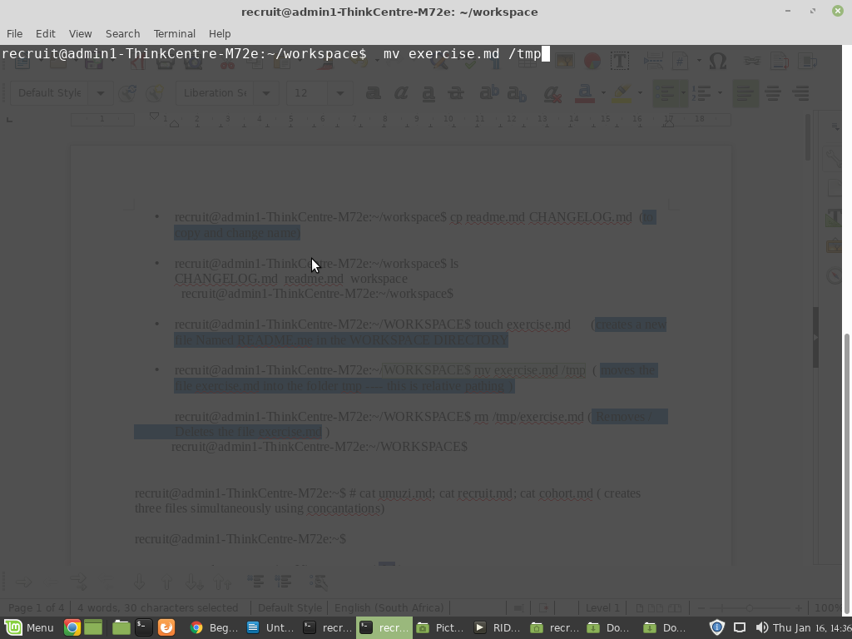

Move the file to the /tmp directory, using a relative path name.

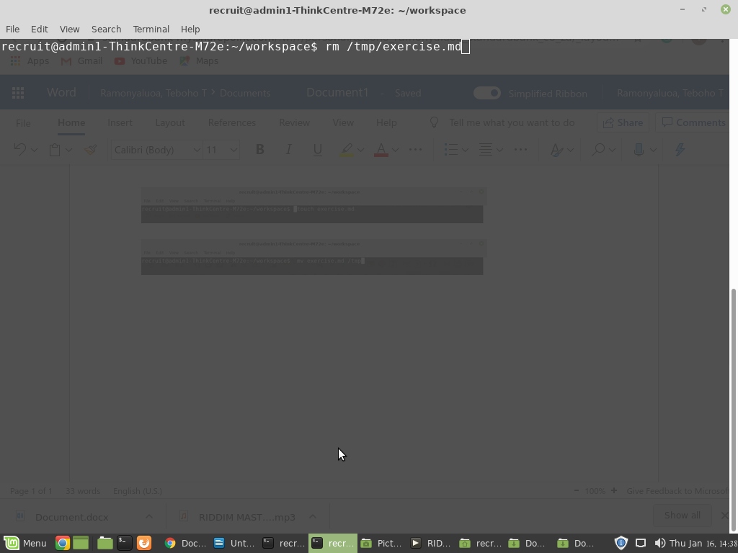

Delete the file using an absolute pathname.